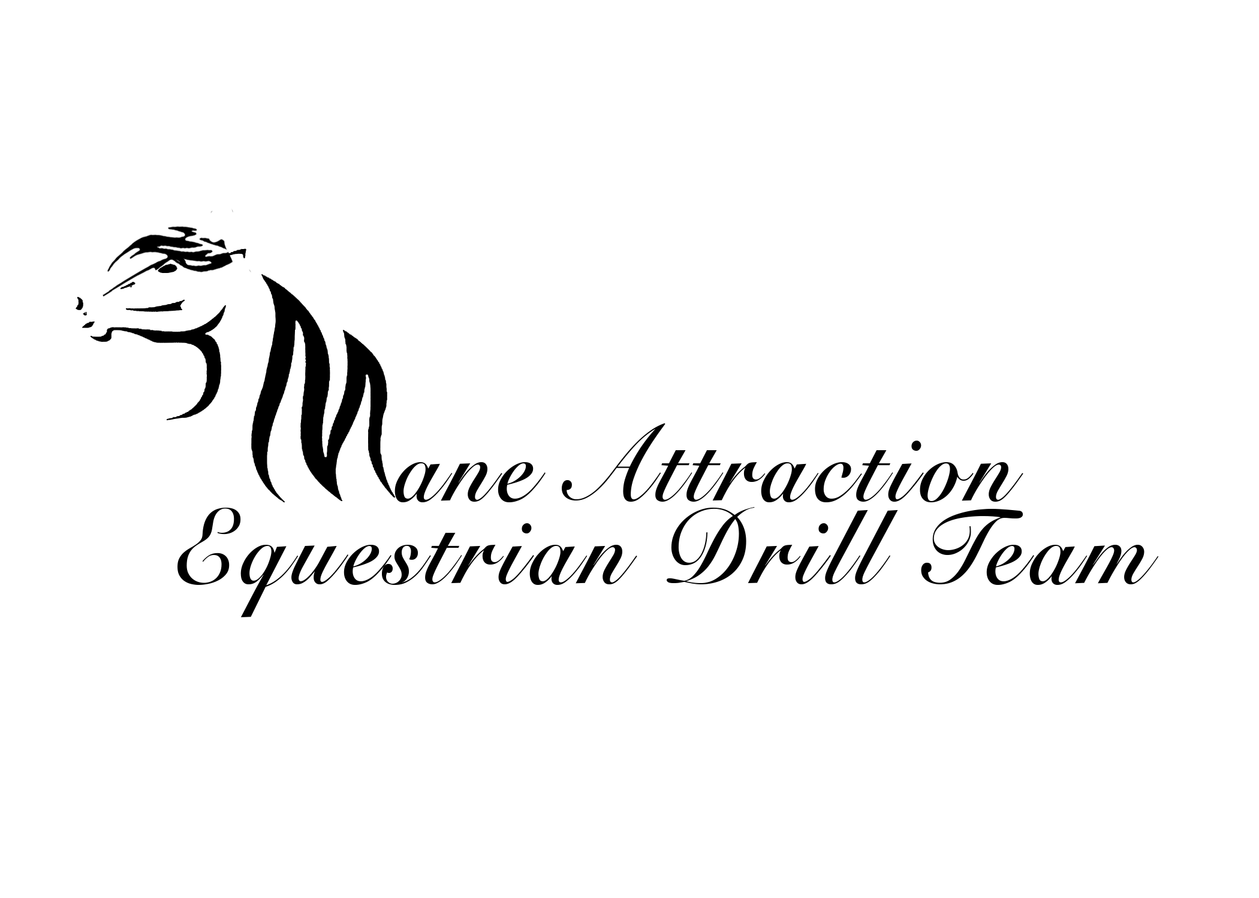

The Mane Attraction Drill Team Contract/By Laws

Mission Statement

“Enjoy life, give and and commit to the ride”

Team Goal

“Give back to the community and make a difference in someone’s life”

The Mane Attraction Drill Team is a team of dedicated women that performs choreographed maneuvers to music. These maneuvers will be performed at fast and slow speeds. You as a rider should be able to ride these speeds in a controlled manner. The Mane Attraction promotes safety and rides with ASTM/SEI-certified helmets. The team rides for and supports many charity groups. The main group we promote is the No Drama Ranch (NDR), a therapeutic riding facility that works with disabled children and adults. As an experienced drill rider, it is important the you understand that riding horses in drill can be dangerous, but it is also very rewarding and fun. There is a risk in this sport, and admittedly, it is not possible to guarantee the safety of horse nor rider, but it is the hope that with some qualification, this risk can be reduced.

While riding on the drill team you will be expected to perform at charity events, horse fairs and evens, rodeos, parades and possibly drill team competitions. You and your horse will perform only when you and your horse are ready to perform. No rider is pressured to perform until they are ready. It is the drill captain’s responsibility to know when a rider and their horse are ready to perform. No rider or horse performs until the drill captain states you are both ready. Every rider is ready at different times. Some riders may be ready in one month, and some may take six months to a year.

If your horse becomes unsafe, or becomes lame, you will be pulled for evaluation. You may use a substitute horse, but only during practice. If the substitute horse gets enough practice time, and proves to be safe and a steady ride, then the substitute horse may be used for performance.

∫ˆDrill Horse Qualification

Drill Horse must be able to walk, trot and canter in a controlled manner.

Drill horse must be able to lope out at high speeds, and slow down or stop when needed.

No lameness issues.

No biting or kicking.

Horse must get along with other horses.

No ponies, gated or draft horses for drill.

Drill Rider Qualifications

Rider must be 18 years or older. If under 18, and approved by board, the rider must be at least 14 years of age, and a parent or guardian must attend all practices and events.

Rider must ride with an ASTM/SEI-certified helmet at all times during practice and performance.

Rider must be able to walk, trot and canter your horse in a controlled manner.

Rider must be able to lope our your horse in a high speed, and be able to slow down or stop your horse.

Rider must attend all practices, every Tuesday and Thursday night, unless it is an emergency, sick, or have special plans scheduled. Please notify drill captain if any such situation comes up.

Rider must pay $20 monthly dues, for insurance purposes, and be able to purchase all tack and drill outfits.

Rider must have their own transportation to drill practices and performances. Ride sharing is encouraged, but is not to be relied upon. If ride sharing, pay your part of the expense (gas and shavings).

Last, but not least, we are a NO DRAMA TEAM! Please keep any drama at home. Rider will have a 30 day trial to see if they and their horse would like to become apart of the Mane Attraction. If rider does decide they want to join, the team will then vote them in.

I (rider) have read this contract and agree to all terms:

_____________________________________________
PRINT NAME

_____________________________________________ ________________________
SIGNATURE DATE

